Docker Task -2
Task Description:
Create a docker file, docker-compose file which when executed must display your basic details in the website.
O/P:
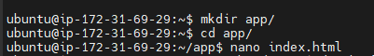
- Create index.html with basic details in the website:
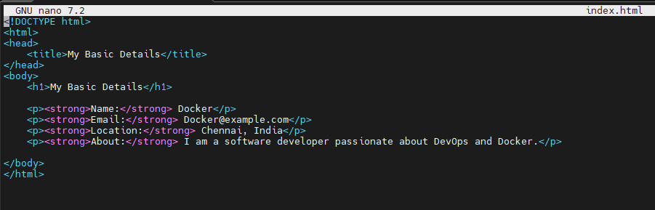

- Create Docker file:
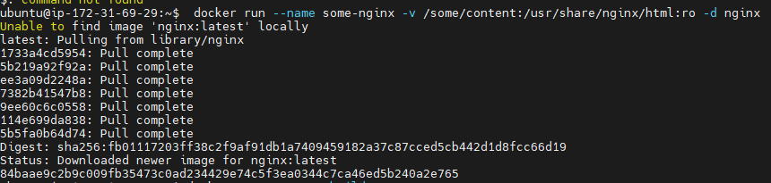
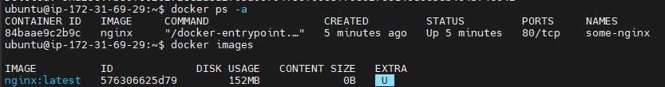
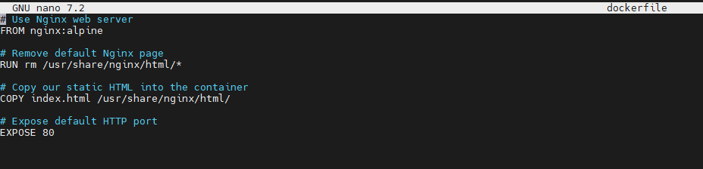
- Create docker-compose.yml:
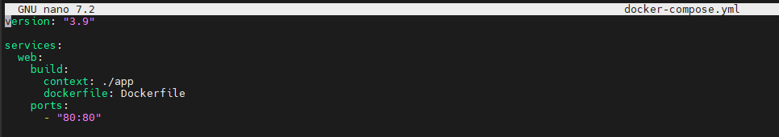
- Executing the ip address in the website:
